Assignment 2

5a. Graphical view of the decision tree

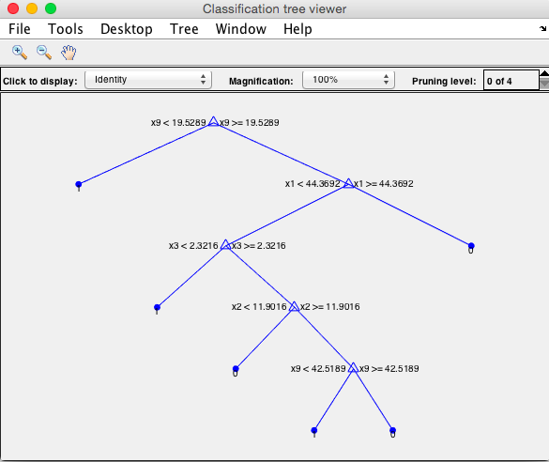

5b).

Results of comparing **training data** actual and predicted values

T =

TP FP FN TN Accuracy Precision Recall

____ ___ ____ ____ ________ _________ _______

8133 308 2519 2060 0.78287 0.96351 0.76352

5c).

Results of comparing **validation data** actual and predicted values

T =

TP FP FN TN Accuracy Precision Recall

____ __ ___ ___ ________ _________ _______

1855 70 614 461 0.772 0.96364 0.75132

6a). Graphical view of the decision tree with minleafnodes 20

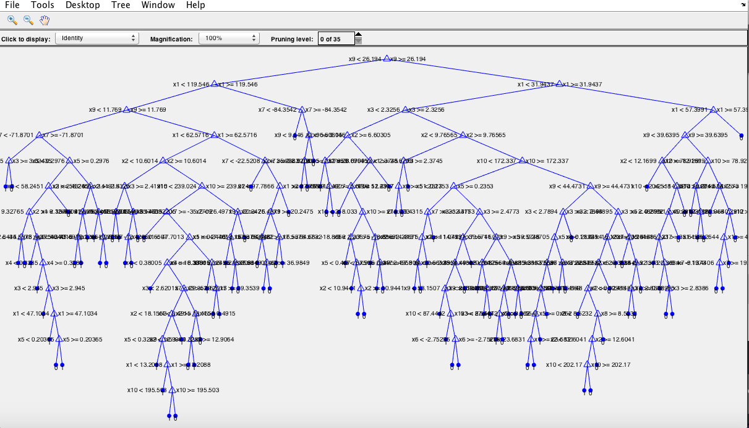

Results of comparing **training data** actual and predicted values

T =

TP FP FN TN Accuracy Precision Recall

____ ___ ___ ____ ________ _________ _______

7816 587 977 3640 0.87988 0.93014 0.88889

Results of comparing **validation data** actual and predicted values

T =

TP FP FN TN Accuracy Precision Recall

____ ___ ___ ___ ________ _________ _______

1811 184 257 748 0.853 0.90777 0.87573

7.

The accuracy of decision trees for the vector of number of leaf nodes 1000, 750, 500, 250, 125, 100, 50, 20, 10, 5 calculated for both training and validation data. Those accuracy values are plotted on the single graph as shown in the following

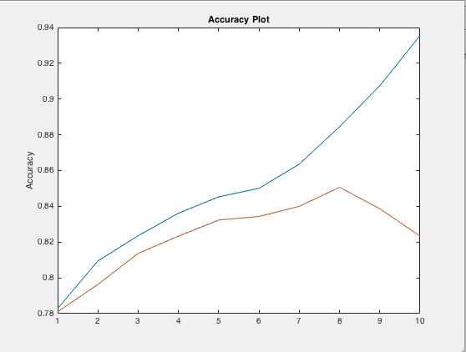

The test data indicated by green plot, the accuracy ranges from 0.78 to 0.93 when the model is tested against training data itself.

But when the model is tested against the validation data the curve raises from 0.78 to 0.85 at the index 8 that means accuracy of the decision tree with minimum number of leaf nodes 20 shows decline in the curve. So that the accuracy till minimum number of leaf nodes from 1000 to 20, the decision tree model is working well. Because that node contains highest accuracy, it is considered best model for the tree.

Train Data: Graph of Number of nodes vs Min no. of leaf Nodes

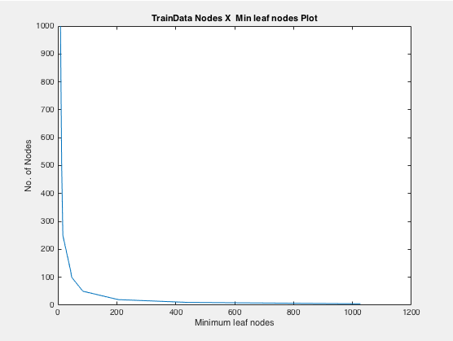

Validation Data: Graph of Number of nodes vs Min no. of leaf Nodes

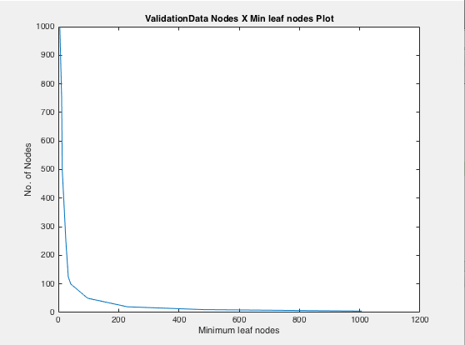

8)

The best model is the decision tree with minimum no. of leaf nodes are 20.

Results of comparing training data actual and predicted values

T =

TP FP FN TN Accuracy Precision Recall ____ ___ ___ ___ ________ _________ _______

1768 172 316 744 0.83733 0.91134 0.84837

No. of Nodes 205

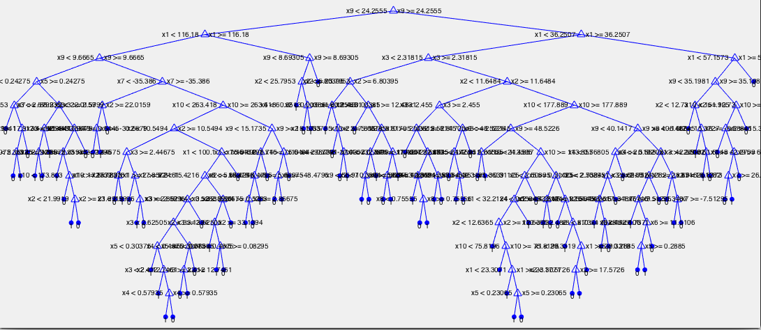

**Matlab Code:**

**% Program 1,**

**% Splitng the data into 3 parts**

MagicData=xlsread('Magic04.xlsx');

T = array2table(MagicData,...

'VariableNames',{'fLength' 'fWidth' 'fSize' 'fConc' 'fConc1'...

'fAsym' 'fM3Long' 'fM3Trans' 'fAlpha' 'fDist' 'class'});

C=table2cell(T);

% Splitting the data into 3 parts training, validation and test data

[TrainData, ValidationData, TestData]=DatasetPartition(MagicData,C);

% Dataset partition function

function [TrainData, ValidationData, TestData]=DatasetPartition(MagicData, Cell)

[rows,columns]=size(MagicData);

randIdx=randperm(rows);

trainIdx=randIdx(1,1:13020);

validationIdx=randIdx(1,13021:16020);

testIdx=randIdx(1,16021:19020);

TrainData=Cell(trainIdx,:);

ValidationData=Cell(validationIdx,:);

TestData=Cell(testIdx,:);

end

**%Program2**

**%Split the training data into two tables: features and classlabels**

MagicData=xlsread('Magic04.xlsx');

T = array2table(MagicData,...

'VariableNames',{'fLength' 'fWidth' 'fSize' 'fConc' 'fConc1'...

'fAsym' 'fM3Long' 'fM3Trans' 'fAlpha' 'fDist' 'class'});

C=table2cell(T);

% Splitting the data into 3 parts training, validation and test data

[TrainData, ValidationData, TestData]=DatasetPartition(MagicData,C);

%seperating features from the training data

Features = TrainData(:,1:10);

Features=cell2mat(Features);

%seperating classlables from the training data

ClassLabels = TrainData(:,11);

ClassLabels=cell2mat(ClassLabels);

**%Program3**

**%Generating decision tree**

MagicData=xlsread('Magic04.xlsx');

T = array2table(MagicData,...

'VariableNames',{'fLength' 'fWidth' 'fSize' 'fConc' 'fConc1'...

'fAsym' 'fM3Long' 'fM3Trans' 'fAlpha' 'fDist' 'class'});

C=table2cell(T);

% Splitting the data into 3 parts training, validation and test data

[TrainData, ValidationData, TestData]=DatasetPartition(MagicData,C);

%constructing decision tree by the conditin of leaf node should

% contain minimum of 600 records

dtr=DesignDecisionTree(TrainData,600);

view(dtr,'Mode','Graph');

**%Program 4**

**%decision tree can be used to find the predicted class labels**

MagicData=xlsread('Magic04.xlsx');

T = array2table(MagicData,...

'VariableNames',{'fLength' 'fWidth' 'fSize' 'fConc' 'fConc1'...

'fAsym' 'fM3Long' 'fM3Trans' 'fAlpha' 'fDist' 'class'});

C=table2cell(T);

% Splitting the data into 3 parts training, validation and test data

[TrainData, ValidationData, TestData]=DatasetPartition(MagicData,C);

dtr=DesignDecisionTree(ValidationData,600)

view(dtr,'Mode','Graph');

%calculating confusion matrix

[TP,FP,FN,TN]=confusionmatrix(ValidationData,dtr);

% calculating probabilities

[Accuracy,Precision,Recall]=InterpretProbability(TP,FP,FN,TN);

**% Program 5**

**% decision tree from training data such that no leaf node has fewer than 1000 records.**

MagicData=xlsread('Magic04.xlsx');

T = array2table(MagicData,...

'VariableNames',{'fLength' 'fWidth' 'fSize' 'fConc' 'fConc1'...

'fAsym' 'fM3Long' 'fM3Trans' 'fAlpha' 'fDist' 'class'});

C=table2cell(T);

% Splitting the data into 3 parts training, validation and test data

[TrainData, ValidationData, TestData]=DatasetPartition(MagicData,C);

%constructing decision tree by the conditin of leaf node should

% contain minimum of 1000 records

dtr=DesignDecisionTree(TrainData,1000);

view(dtr,'Mode','Graph');

%calculating confusion matrix for training data

[ConfMat]=confusionmatrix(TrainData,dtr);

fprintf('Results of comparing training data actual and predicted values');

T = array2table(ConfMat,...

'VariableNames',{'TP' 'FP' 'FN' 'TN' 'Accuracy'...

'Precision' 'Recall'})

[ConfMat]=confusionmatrix(ValidationData,dtr);

fprintf('Results of comparing validation data actual and predicted values');

T = array2table(ConfMat,...

'VariableNames',{'TP' 'FP' 'FN' 'TN' 'Accuracy'...

'Precision' 'Recall'})

**%Program6**

**%no leaf node has fewer than 20 records.**

MagicData=xlsread('Magic04.xlsx');

T = array2table(MagicData,...

'VariableNames',{'fLength' 'fWidth' 'fSize' 'fConc' 'fConc1'...

'fAsym' 'fM3Long' 'fM3Trans' 'fAlpha' 'fDist' 'class'});

C=table2cell(T);

% Splitting the data into 3 parts training, validation and test data

[TrainData, ValidationData, TestData]=DatasetPartition(MagicData,C);

%constructing decision tree by the conditin of leaf node should

% contain minimum of 1000 records

dtr=DesignDecisionTree(TrainData,20);

view(dtr,'Mode','Graph');

%calculating confusion matrix for training data

[ConfMat]=confusionmatrix(TrainData,dtr);

fprintf('Results of comparing training data actual and predicted values');

T = array2table(ConfMat,...

'VariableNames',{'TP' 'FP' 'FN' 'TN' 'Accuracy'...

'Precision' 'Recall'})

[ConfMat]=confusionmatrix(ValidationData,dtr);

fprintf('Results of comparing validation data actual and predicted values');

T = array2table(ConfMat,...

'VariableNames',{'TP' 'FP' 'FN' 'TN' 'Accuracy'...

'Precision' 'Recall'})

**% Program 7**

MagicData=xlsread('Magic04.xlsx');

T = array2table(MagicData,...

'VariableNames',{'fLength' 'fWidth' 'fSize' 'fConc' 'fConc1'...

'fAsym' 'fM3Long' 'fM3Trans' 'fAlpha' 'fDist' 'class'});

C=table2cell(T);

% Splitting the data into 3 parts training, validation and test data

[TrainData, ValidationData, TestData]=DatasetPartition(MagicData,C);

MinLeafNodes=[1000, 750, 500, 250, 125, 100, 50, 20, 10, 5];

%constructing decision tree by the conditin of leaf node should

% contain minimum of 1000 records

TestNumNodes=0;

ValidNumNodes=0;

TestAccuracy=0;

ValidaAccuracy=0;

for idx=1:length(MinLeafNodes)

dtr=DesignDecisionTree(TrainData,MinLeafNodes(1,idx));

%calculating confusion matrix for training data

[ConfMat]=confusionmatrix(TrainData,dtr);

TestAccuracy(idx,1)=ConfMat(1,5);

TestNumNodes(idx,1)=dtr.NumNodes;

[ConfMat]=confusionmatrix(ValidationData,dtr);

ValidaAccuracy(idx,1)=ConfMat(1,5);

ValidNumNodes(idx,1)=dtr.NumNodes;

end

figure();

plot(TestAccuracy);

title('Accuracy Plot');

ylabel('Accuracy');

hold on

plot(ValidaAccuracy);

ylabel('Accuracy');

hold off

figure();

plot(TestNumNodes,MinLeafNodes);

title('TrainData Nodes X Min leaf nodes Plot');

xlabel('Minimum leaf nodes');

ylabel('No. of Nodes');

figure();

plot(ValidNumNodes,MinLeafNodes);

title('ValidationData Nodes X Min leaf nodes Plot');

xlabel('Minimum leaf nodes');

ylabel('No. of Nodes');

**%Program 8**

MagicData=xlsread('Magic04.xlsx');

T = array2table(MagicData,...

'VariableNames',{'fLength' 'fWidth' 'fSize' 'fConc' 'fConc1'...

'fAsym' 'fM3Long' 'fM3Trans' 'fAlpha' 'fDist' 'class'});

C=table2cell(T);

% Splitting the data into 3 parts training, validation and test data

[TrainData, ValidationData, TestData]=DatasetPartition(MagicData,C);

%constructing decision tree by the conditin of leaf node should

% contain minimum of 1000 records

dtr=DesignDecisionTree(TrainData,20);

view(dtr,'Mode','Graph');

%calculating confusion matrix for training data

[ConfMat]=confusionmatrix(TestData,dtr);

fprintf('Results of comparing training data actual and predicted values');

T = array2table(ConfMat,...

'VariableNames',{'TP' 'FP' 'FN' 'TN' 'Accuracy'...

'Precision' 'Recall'})